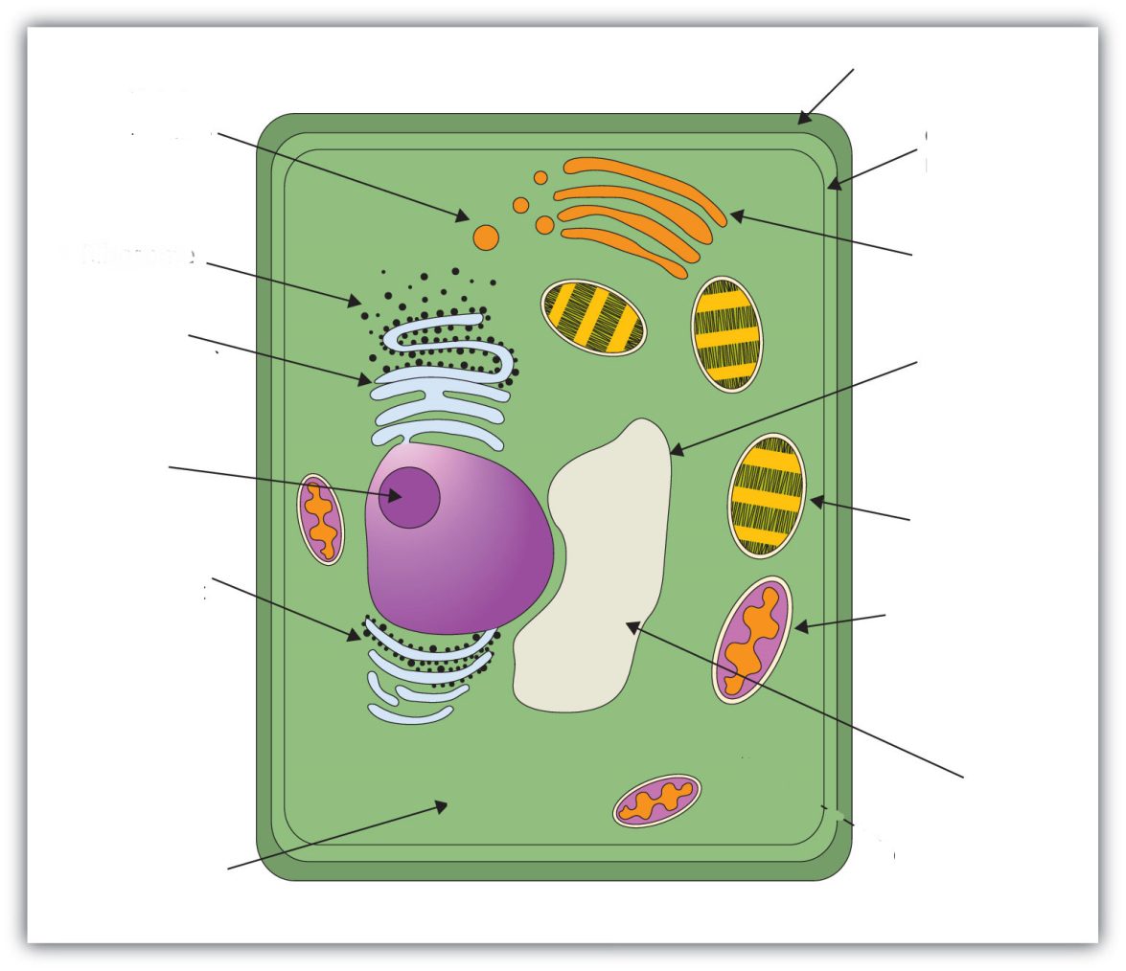
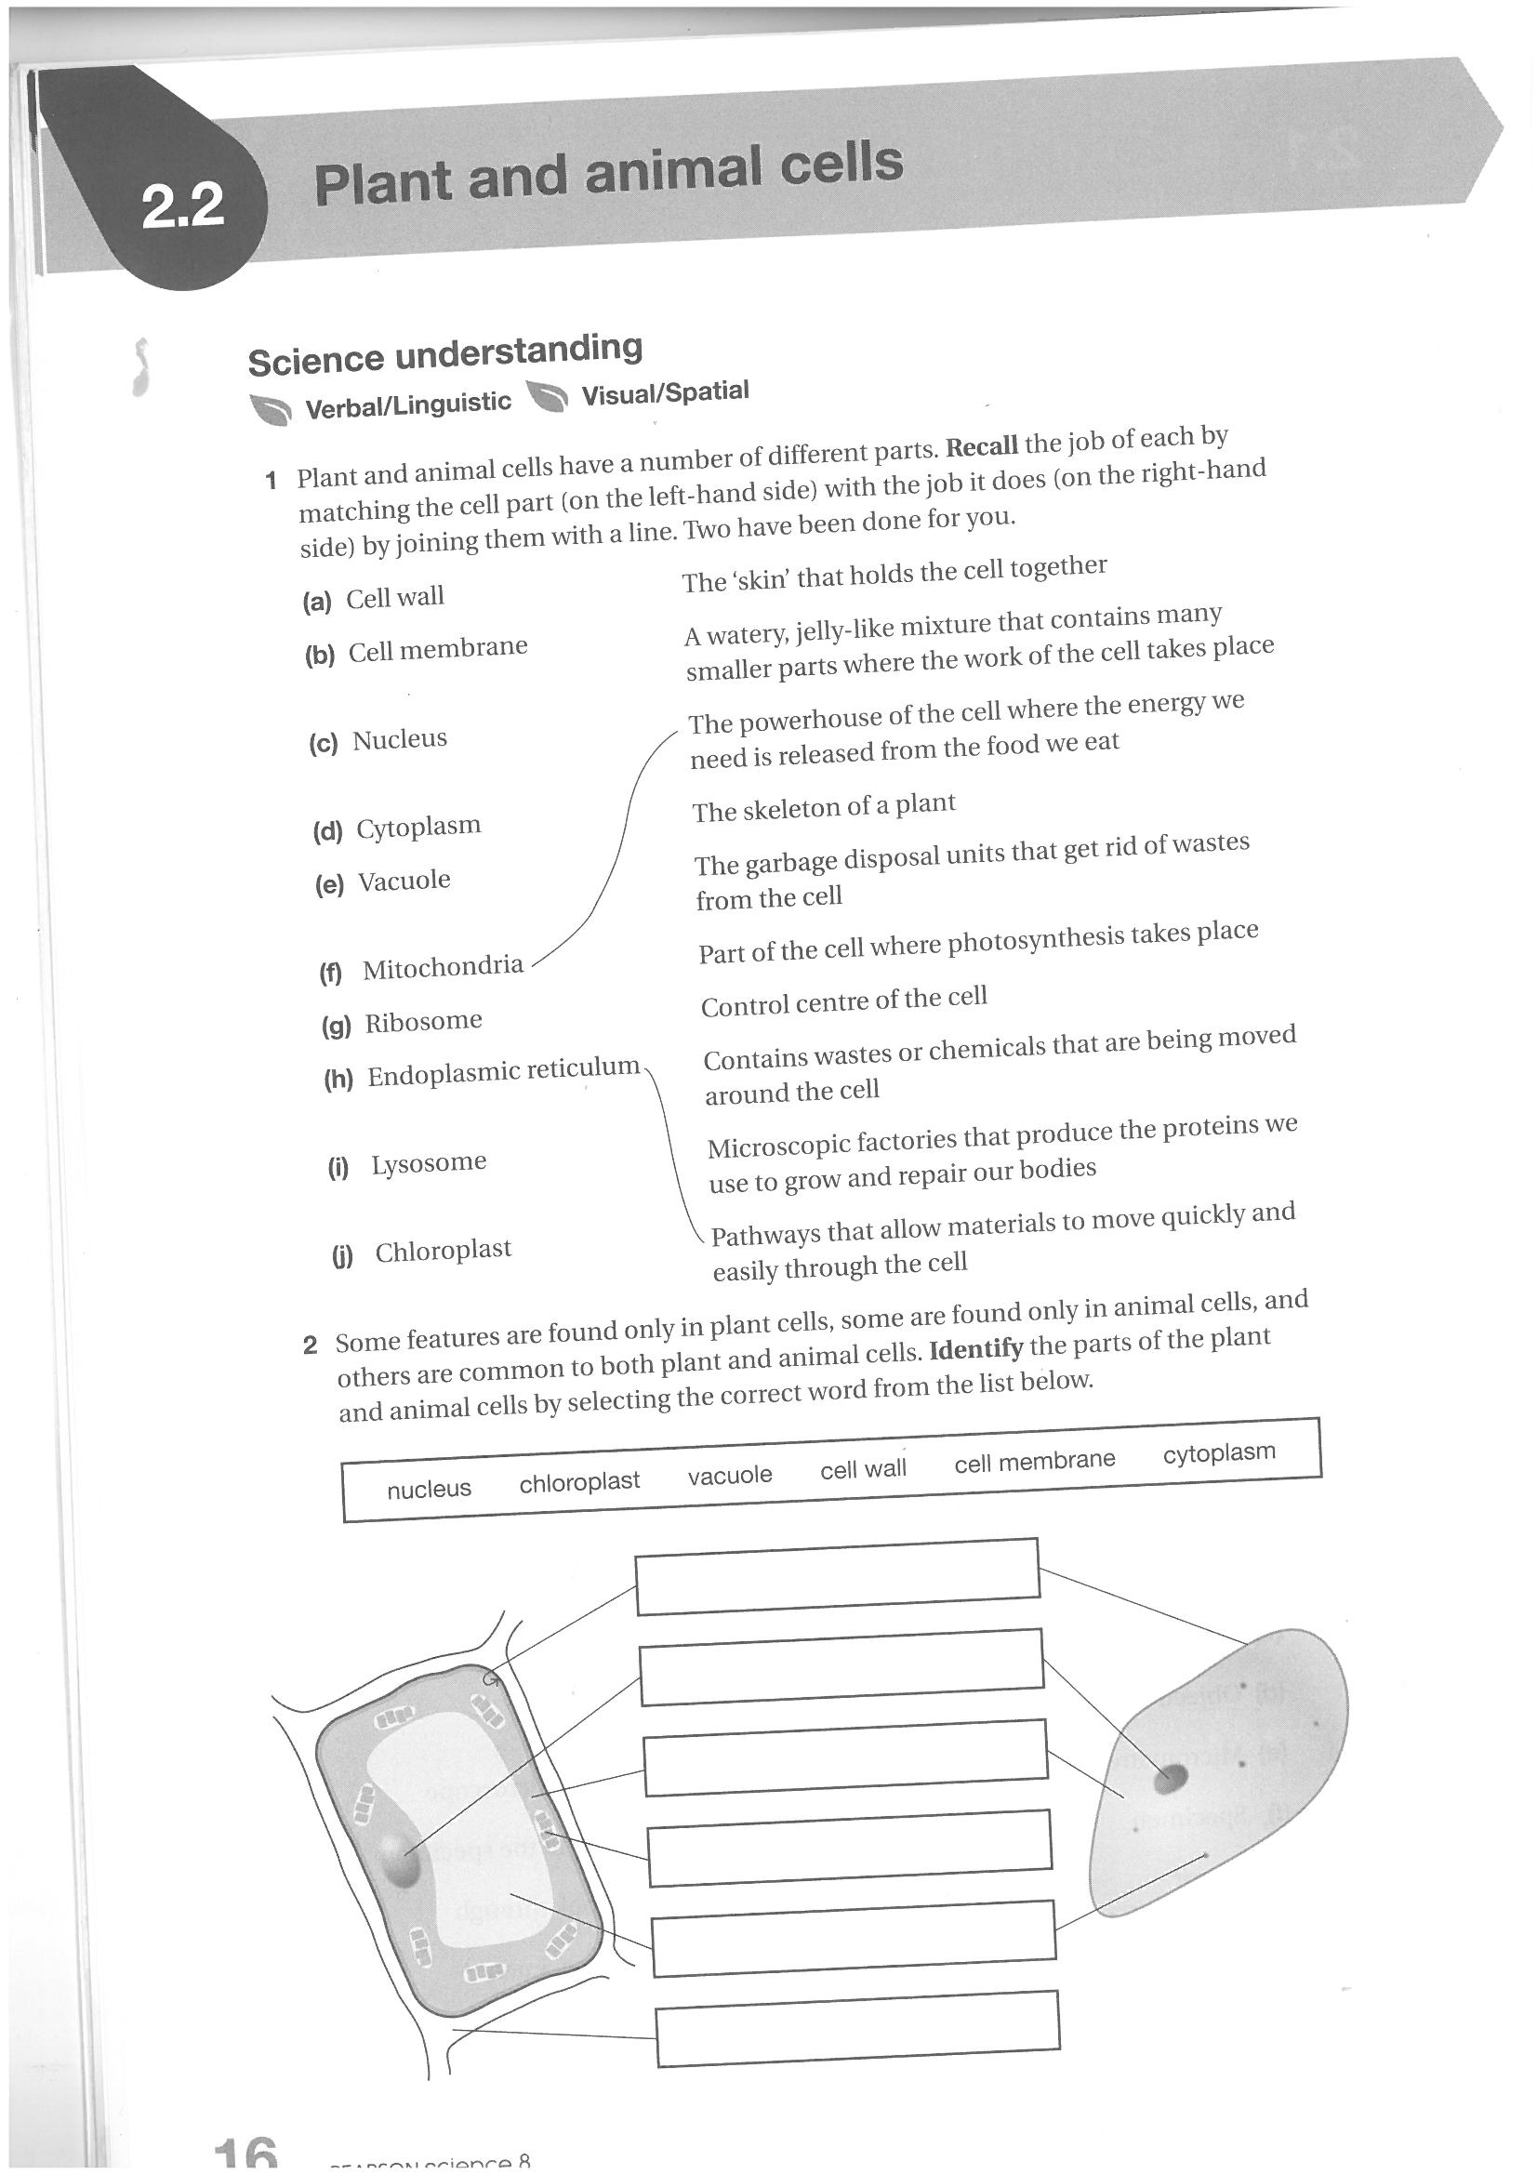
Label the cell below
Organelle | Represented by | What it’s role/function is in a real cell
Nucleus
Ribosomes
Chloroplasts
Cell Wall
Rough ER
Smooth ER
Lysosomes
Golgi Bodies
Mitochondria
Draw a clearly labelled diagram below of your biscuit cell.

